JUnit Testing Exercises

Exercise 1: Setting Up Junit
Scenario: You need to set up JUnit in your Java project to start writing unit tests.

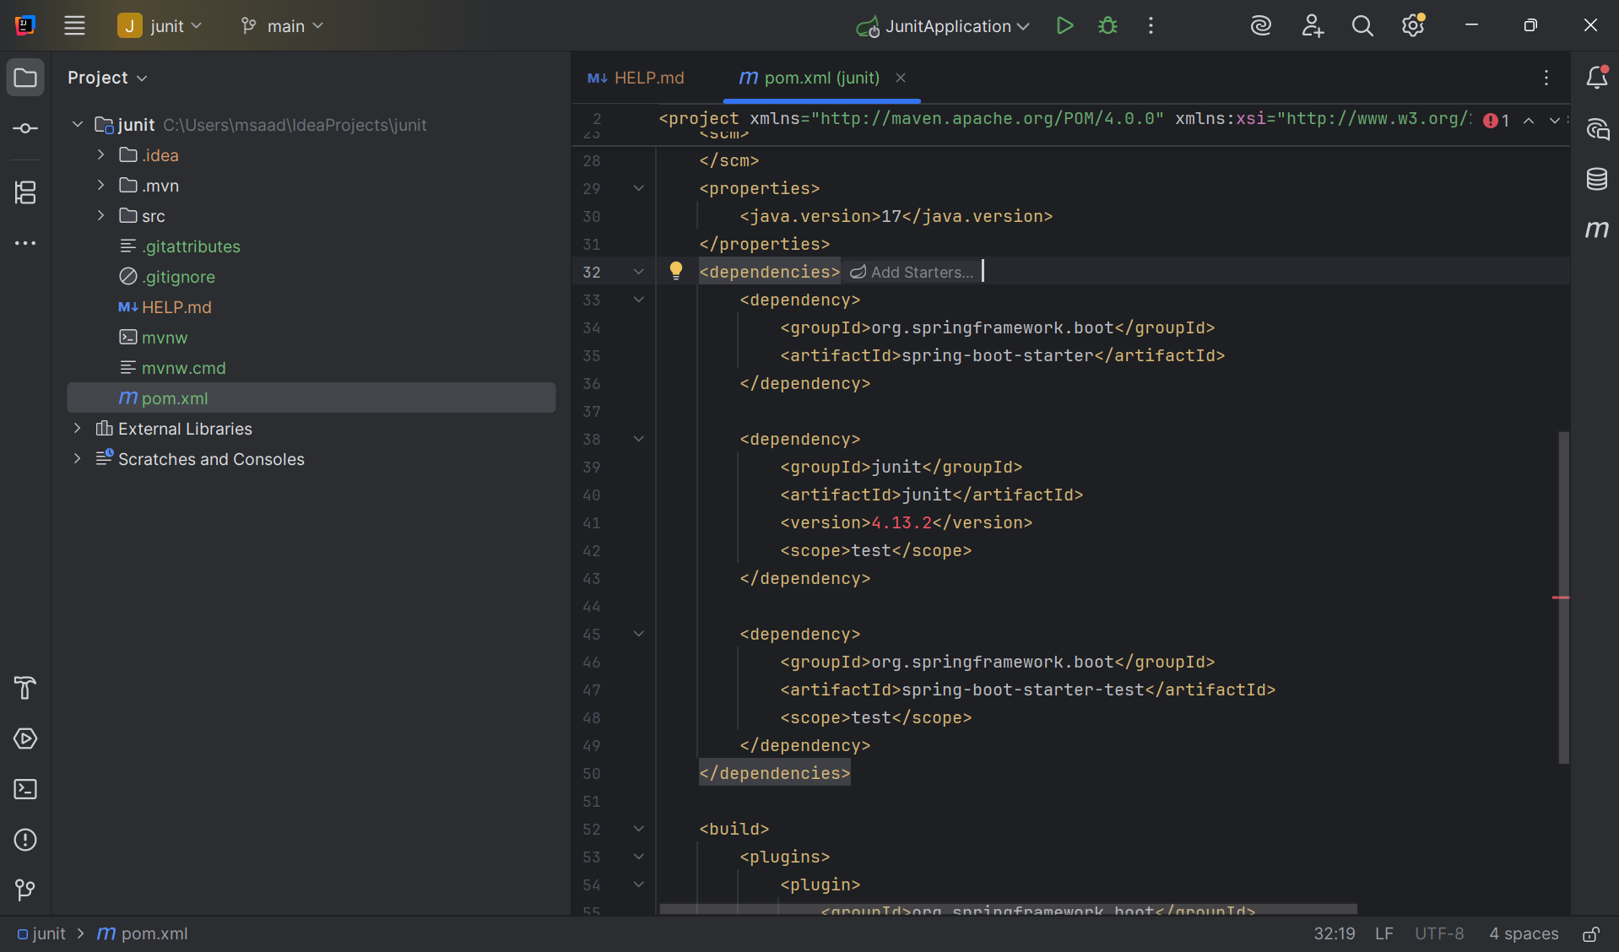

Exercise 3: Assertions in JUnit
Scenario: You need to use different assertions in JUnit to validate your test results.

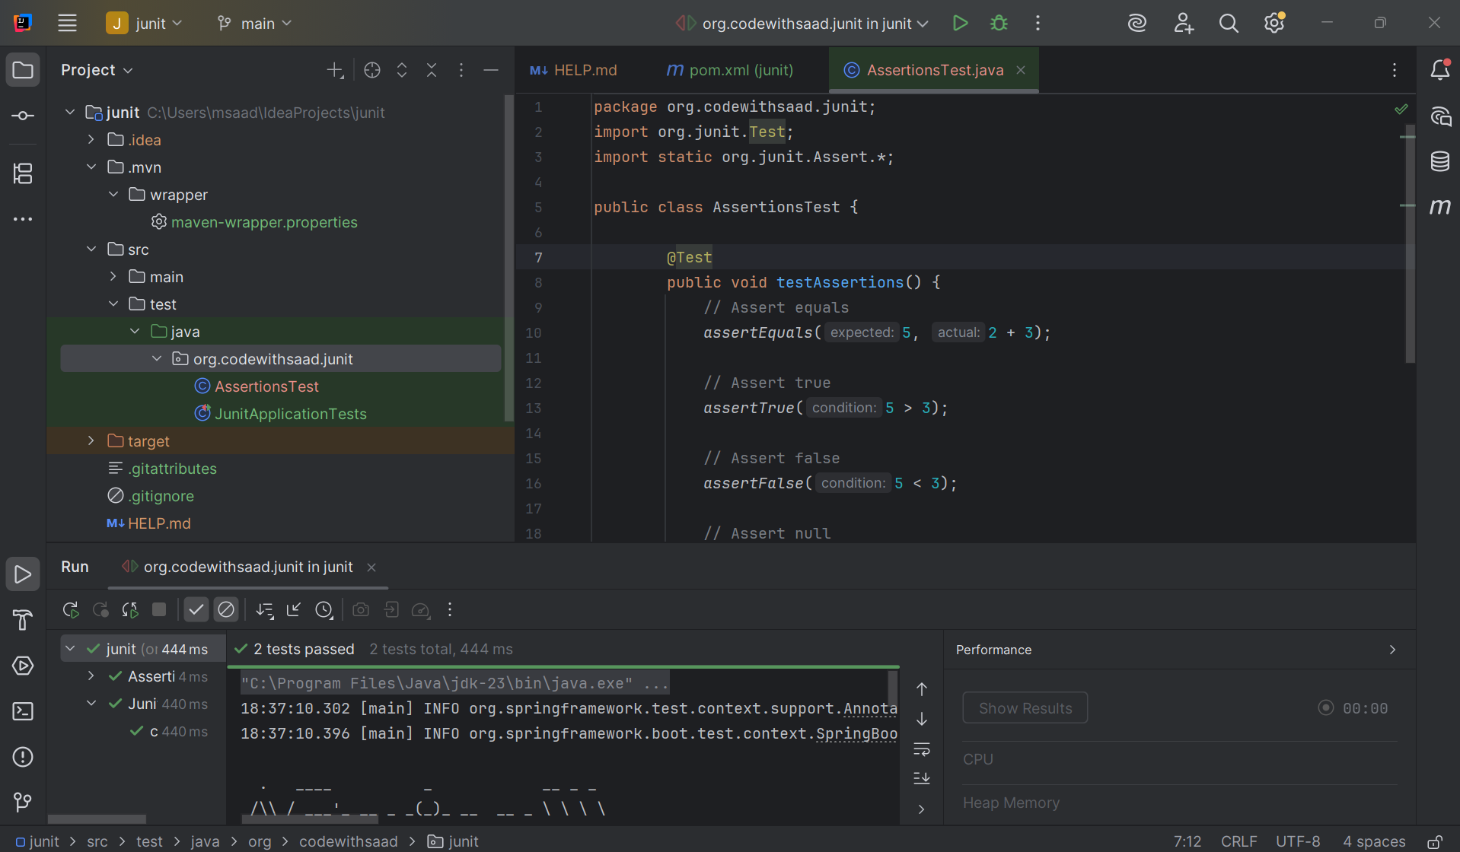

Exercise 4: Arrange-Act-Assert (AAA) Pattern, Test Fixtures, Setup and Teardown Methods in JUnit
Scenario: You need to organize your tests using the Arrange-Act-Assert (AAA) pattern and use setup and teardown methods.
Calculator.java
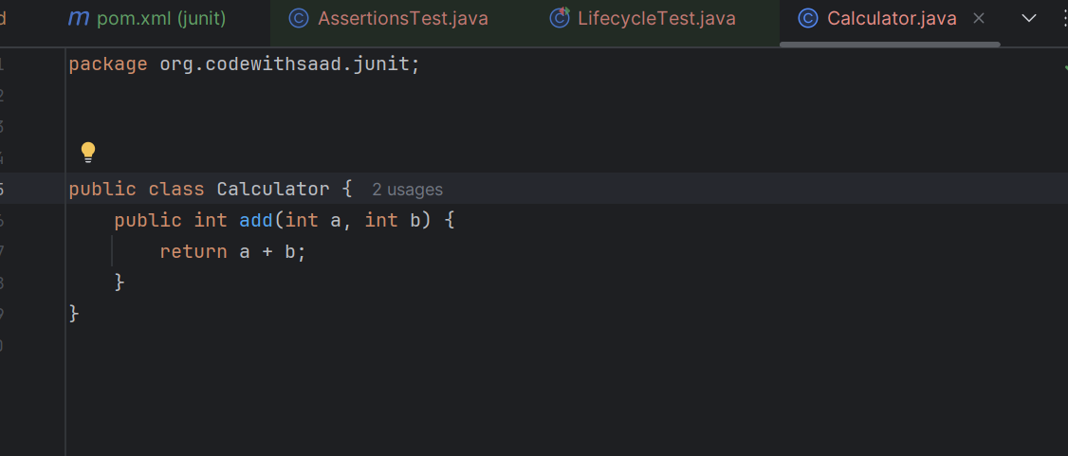
LifecycleTest.java

package org.codewithsaad.junit;
import org.junit.After;
import org.junit.Before;
import org.junit.Test;
import static org.junit.Assert.*;
public class LifecycleTest {
private Calculator calc;
@Before
public void setUp() {
calc = new Calculator();
System.out.println("Setup completed.");
}
@Test
public void testAdd() {
// Arrange done in setup
// Act
int result = calc.add(2, 3);
// Assert
assertEquals(5, result);
}
@After
public void tearDown() {
System.out.println("Teardown completed.");
}
}

Output:
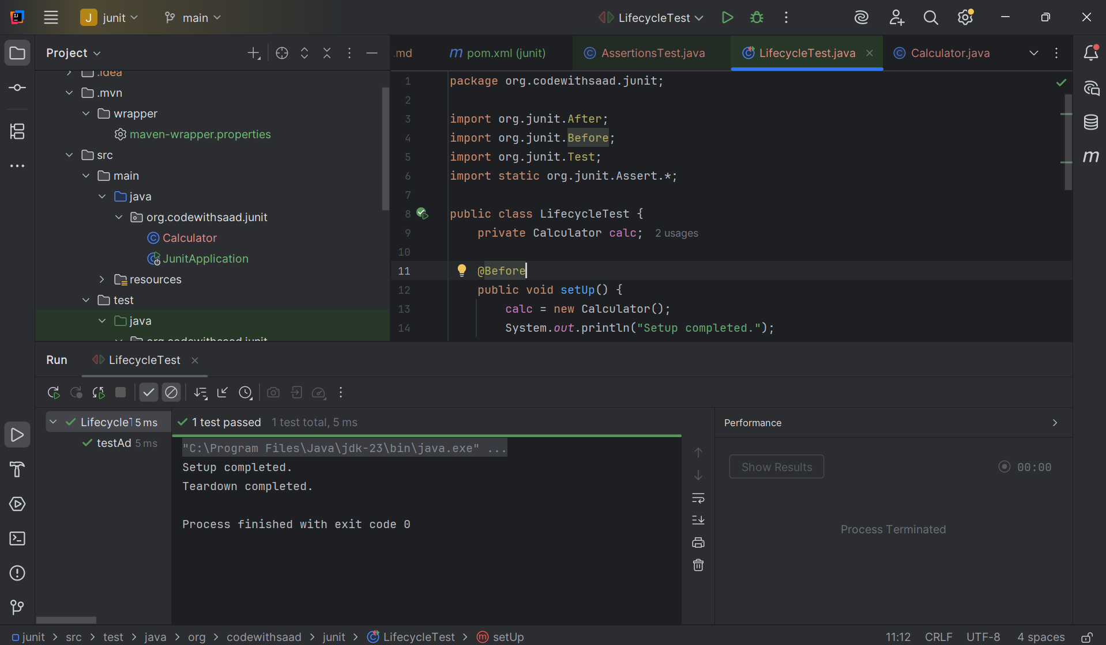

Mockito Hands-On Exercises
Exercise 1: Mocking and Stubbing
Scenario: You need to test a service that depends on an external API. Use Mockito to mock the external API and stub its methods.

ExternalApi.java
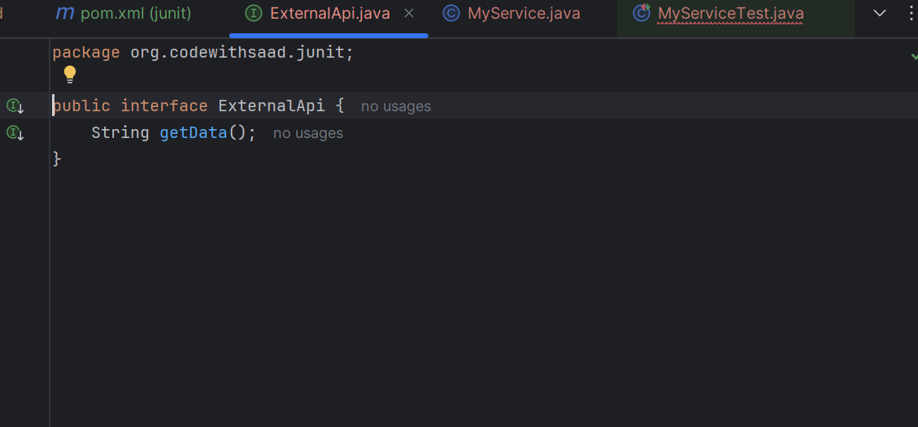

MyServiceTest.java
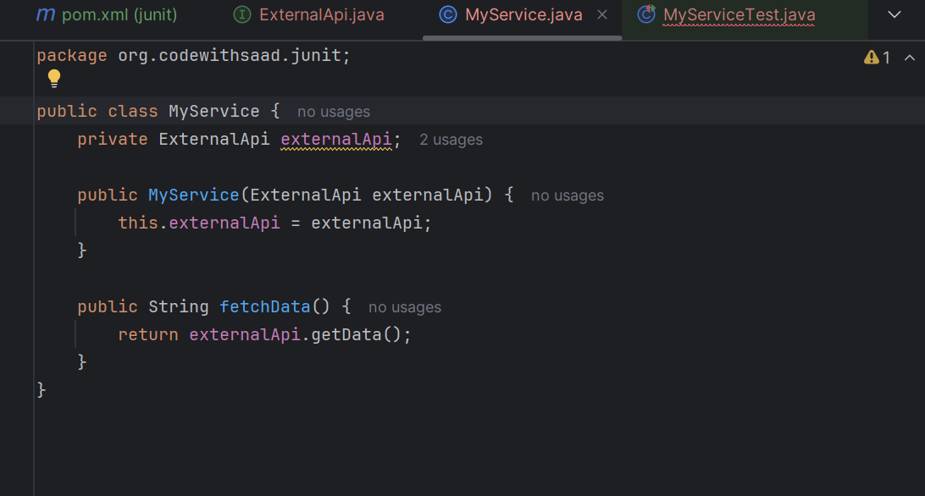
MyServiceTest.java (testing code)
package org.codewithsaad.junit;
package org.codewithsaad.mockito;
import org.junit.jupiter.api.Test;
import static org.mockito.Mockito.*;
import static org.junit.jupiter.api.Assertions.*;
public class MyServiceTest {
@Test
public void testExternalApi() {
// Arrange: Mock
ExternalApi mockApi = mock(ExternalApi.class);
// Stub: when().thenReturn()
when(mockApi.getData()).thenReturn("Mock Data");
// Act: Use the mock in your service
MyService service = new MyService(mockApi);
String result = service.fetchData();
// Assert
assertEquals("Mock Data", result);
}
}
Output:
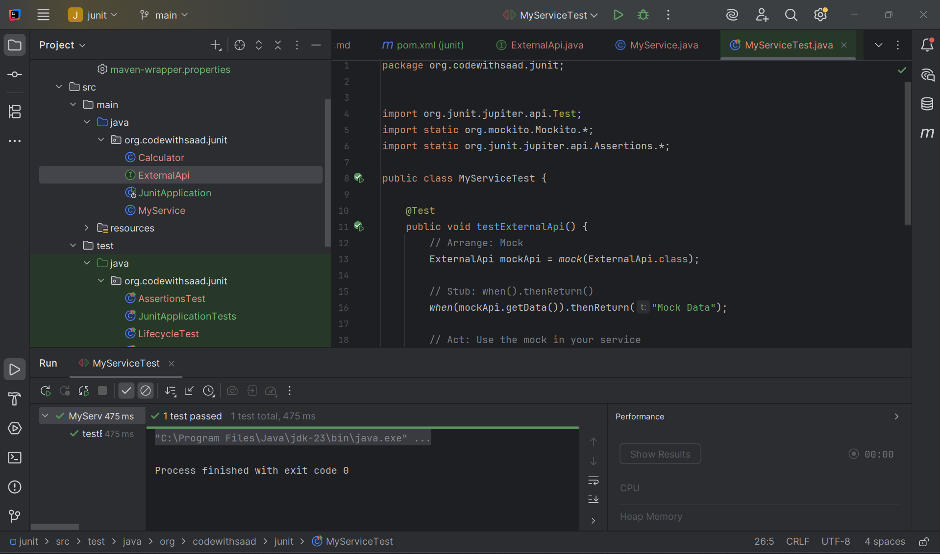
Exercise 2: Verifying Interactions
Scenario: You need to ensure that a method is called with specific arguments.

In the above testing code we add another piece of code,
@Test
public void testVerifyInteraction() {
// Arrange: Mock
ExternalApi mockApi = mock(ExternalApi.class);

// Act: Use the mock
MyService service = new MyService(mockApi);
service.fetchData();

// Assert: Verify that getData() was called
verify(mockApi).getData();
}

Output:
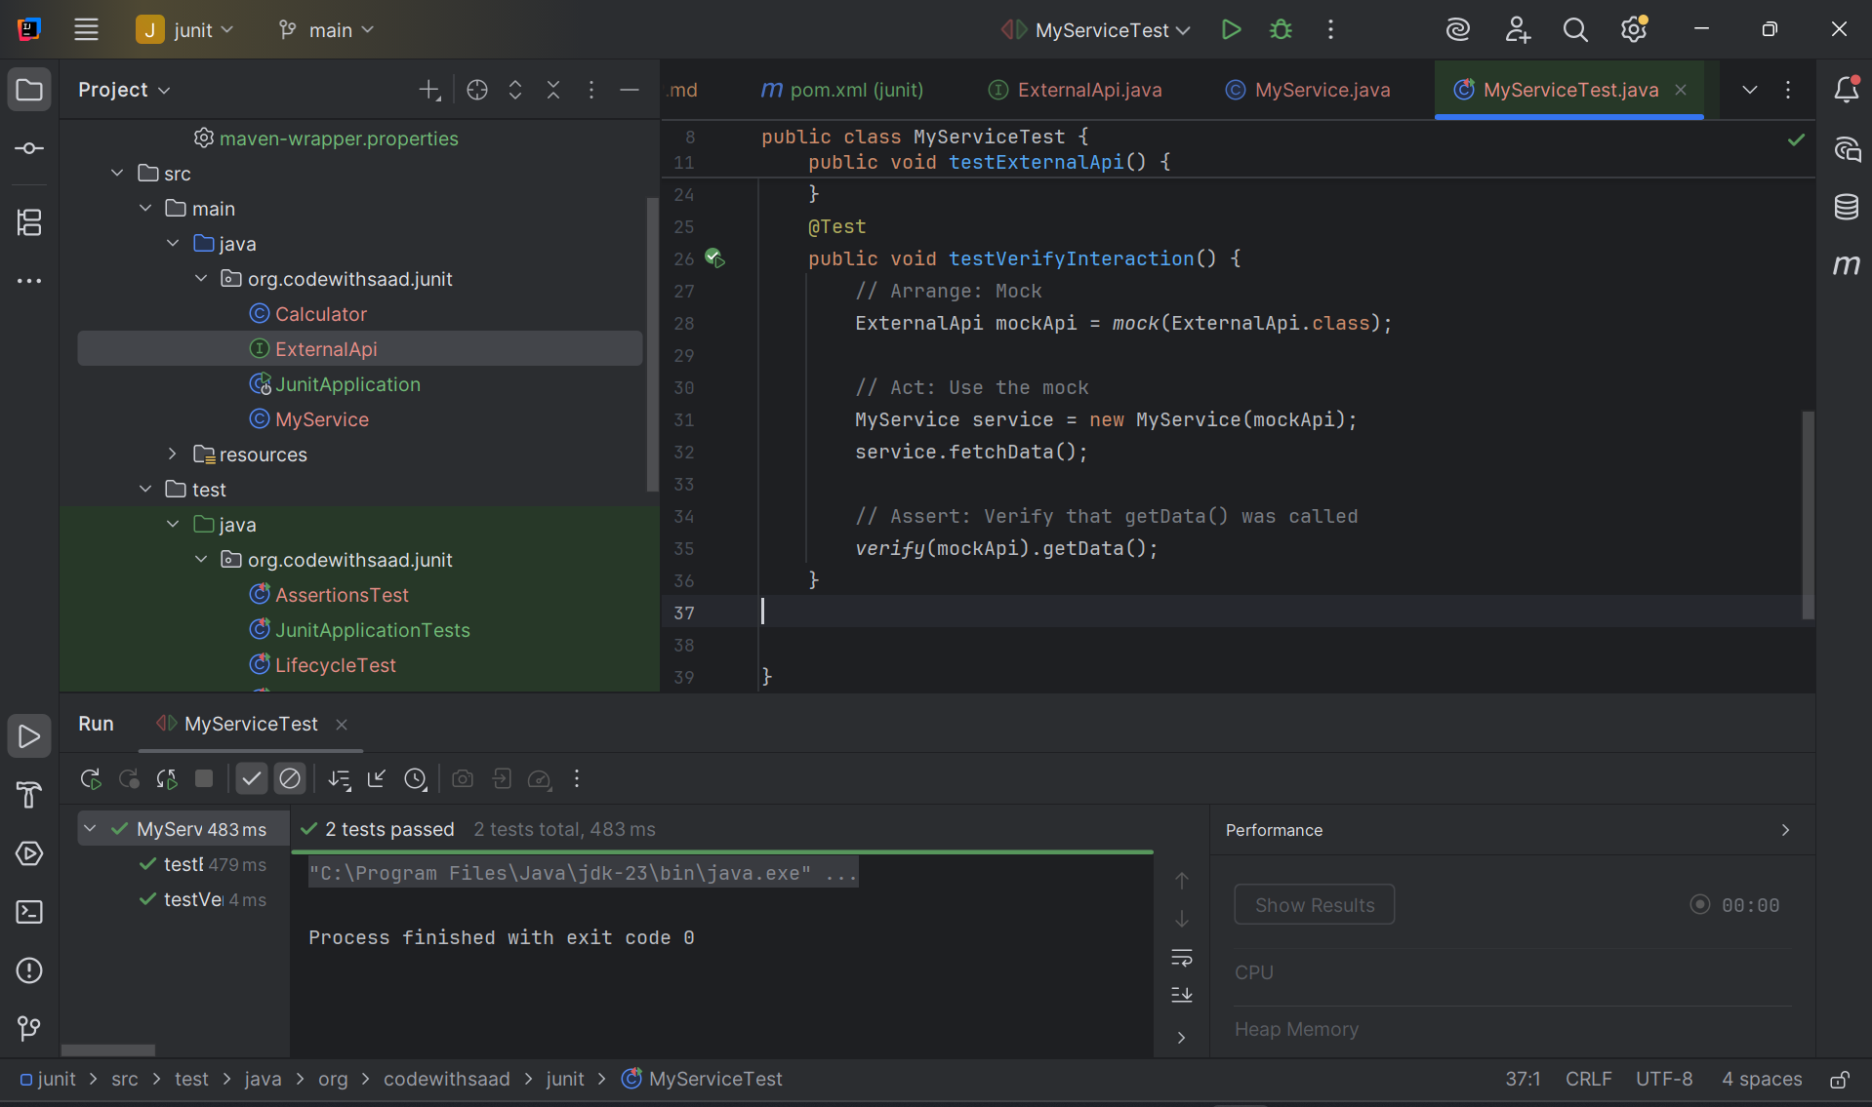
Logging using SLF4J

Exercise 1: Logging Error Messages and Warning Levels
Task: Write a Java application that demonstrates logging error messages and warning levels
using SLF4J.

I am not adding the dependencies given in the handbook as the dependencies are already integrated in my IntelliJ IDE

LoggingExample.java
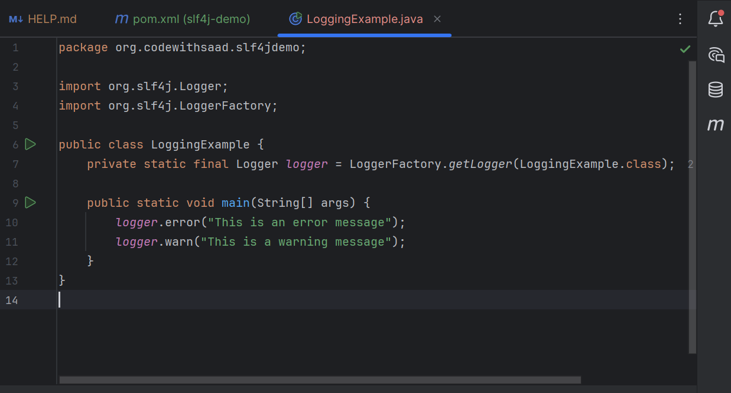

Output:
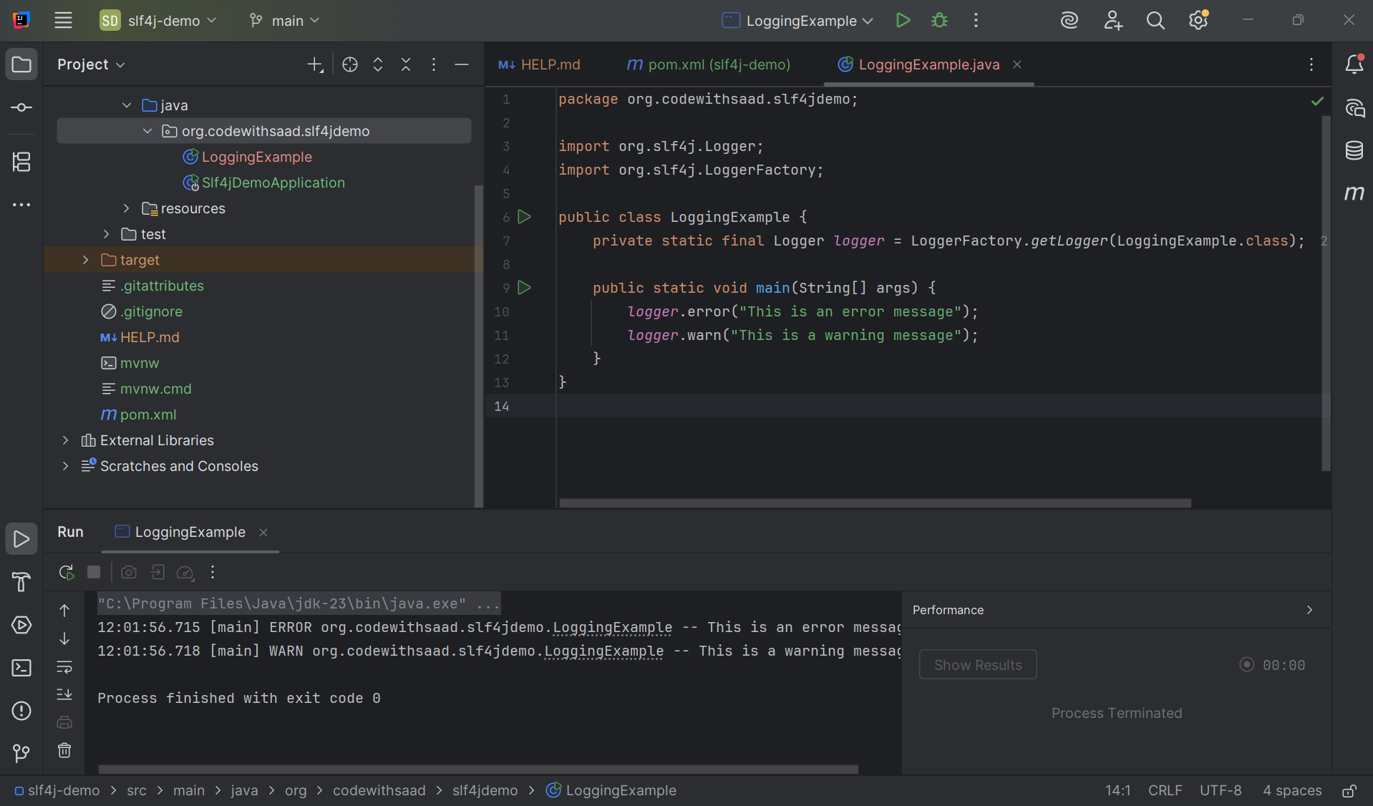

__________________________ThankYou___________________

